**Aim:**

To demonstrate Platform as a Service (PaaS) by creating and configuring a platform instance (Web App) in Microsoft Azure Public Cloud.

**Procedure:**

1. Login to Azure Portal

* Open https://portal.azure.com
* Sign in with your Azure account.

2. Create a Resource Group

* In the search bar, type Resource Groups → Create.
* Provide a name (e.g., PaaS-RG).
* Choose a Region → Click Review + Create → Create.

3. Create an App Service (Web App)

* In the search bar, type App Services → Create → Web App.
* Select your Resource Group (PaaS-RG).
* Enter a Name for your Web App (e.g., paas-demo-app).
* Choose Publish = Code.
* Select Runtime Stack (e.g., .NET, Node.js, Python).
* Select Region (same as Resource Group).
* Choose or create an App Service Plan (Azure manages CPU, RAM, and OS in the background).

4. Deploy Application Code

* In the Web App → Deployment Center, connect GitHub, local Git, or upload code directly.
* Azure automatically manages scaling, patching, and runtime environment.

5. Access the Application

* After deployment, go to the Overview tab of your Web App.
* Copy the default URL (e.g., https://paas-demo-app.azurewebsites.net).
* Open in browser → Verify the app runs.

**OUTPUT:**

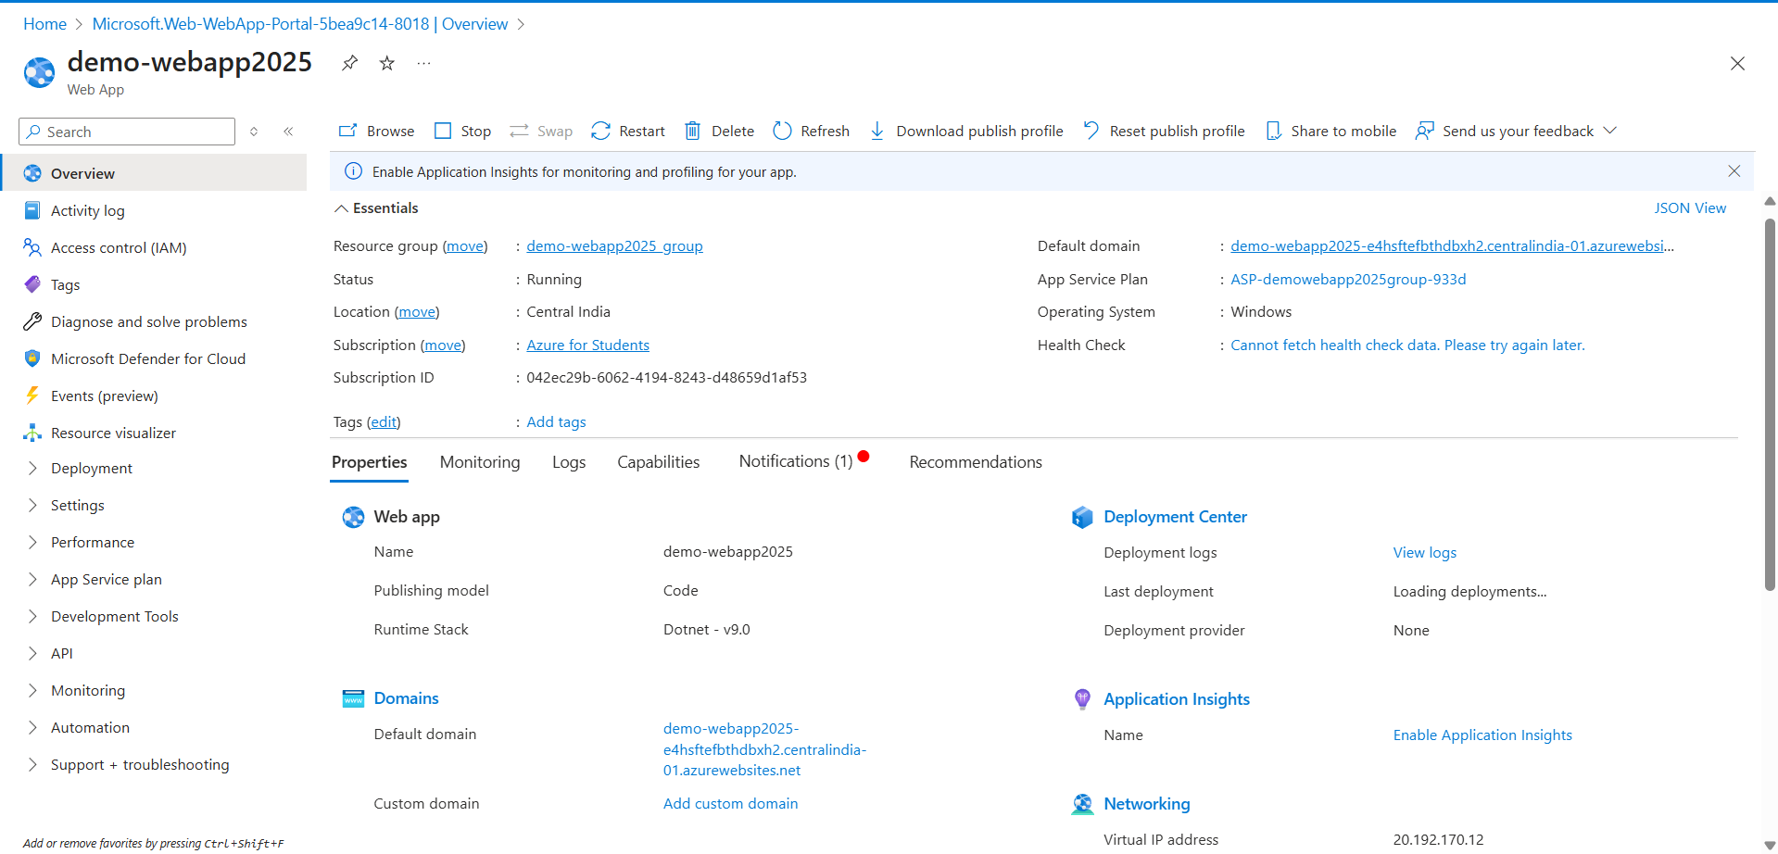

**Result:**

A Platform as a Service (PaaS) environment was successfully demonstrated using Microsoft Azure App Service. A Web App was created and deployed without manual VM/OS configuration, showing that the cloud provider manages infrastructure, scaling, and runtime environment automatically